I-CReSt 2020
Universiti Teknologi MARA Cawangan Selangor, Kampus Dengkil, Malaysia, 4th July 2020

Full Paper Template for International Conference on Research and Practices in Science, Technology and Social Sciences (I-CReST) 2020

*¹First Author (Full Name), ^{1,2}Second Author (Full Name), ³Third Author (Full Name)

^{1,2}Authors’ Department, Institute, City, Country
³Centre of Foundation Studies, Universiti Teknologi MARA, Cawangan Selangor, Kampus Dengkil, 43800 Dengkil, Selangor, Malaysia

*E-mail: corresponding author’s email address

ABSTRACT

All manuscripts must be accompanied by an abstract of not more than 300 words, written in English. The abstract summarises the major aspects of a paper. It allows readers to glance through the contents of an article quickly. The abstract should contain a concise description of the study which includes (i) problem statement(s) or objective(s); (ii) materials and method/theoretical framework; (iii) summary of major findings; and (iv) a brief conclusion.

Keywords: Keyword 1; keyword 2; keyword 3 (Min 3 keywords & Max 5 keywords)

INTRODUCTION

This template explains and demonstrates how to prepare your I-CReST 2020 final manuscript or full paper to be considered in either a proceeding or a journal publication. Please read and adhere to the formatting instruction. The easiest way to do this is replace the words written in red fonts with your own.

Authors are requested to submit the full paper of 6 to 8 pages in length in electronic form of MS-Word via our online submission page. Page format should be A4 page sized (21 x 29.7 cm or 8 x 11 in) with margins 2.5 cm (0.98 in) wide from the right, left, top and bottom. Use 12-point Times New Roman font, single line spacing and justified alignment. The manuscript must be written according to the following Sections Headings: Introduction, Body, and Conclusion. Subsections (Second Level Headings) can be included. Please indent the text paragraphs, except the first paragraph in Section Headings/Second Level Headings.

Authors must make sure that the research problems are well defined in the introduction. The objectives must be clearly stated, measurable/assessable, and can be met by the research methodology/design used. Review of related literature must be relevant to the research issue(s), comprehensive and well-reviewed, organised, and summarised.

All references should be cited in the text by square brackets [1]. Two or more references at a time may be put in one set of brackets [1,2]. The references are to be listed and numbered in the order in which they are cited in the manuscript under the heading, References [1-3].

- BODY

Body can be organised into few Section Headings in many ways. Experimental research typically includes Materials & Methods, and Results & Discussion. Non-experimental research may include Conceptual Framework, Recommendation for Experimentation, etc. In any case, choose whichever is relevant to your work.

Subsections/Second-level Headings

Subsections/Second-level Headings (if any) are typed in boldface with capitalised first letter(s), as shown above.

Figures

Figures can be included in your paper and referred to as Figure 1, Figure 2, and so on. All the figures should be centered, with the header placed under the image.

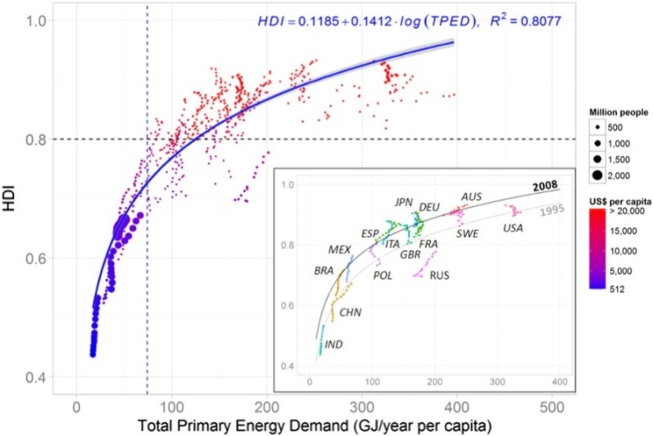

Figure 1: Human development index, total primary energy demand per capita and GDP per capita of selected countries, 1995-2008 [9]

Tables

All tables should be inserted (see sample below) and labelled as Table 1, Table 2, and so on. The header for each of the tables should be centred and placed at the top.

Table 1: Example of table

Contents of Table

Equations

Equations should be labelled as follows: (1), (2) ...). It is recommended to include a space above and below the equation respectively to segregate it from the text. The equations must be numbered sequentially, with the numbers placed in parentheses at the right-hand edge of the texts.
c² = a² + b² (1)

Special Symbols

Symbols such as α γ μ Ω () ≥ ± ● Γ {110} should be written in Times New Roman or Arial, and these include the ones listed in the figures and tables.

3. CONCLUSION

The conclusion should answer the research objectives. In specific, it should include the following: (1) the principles and generalisations inferred from the results; (2) any perceptions, problems, or limitations of the work; (3) theoretical and/or implications of the work; and (4) recommendations for future work.

ACKNOWLEDGEMENT

The authors can add in the acknowledgement to express their appreciation for the support of the sponsors. This should include details such as Project No, individual(s), or name(s) of organisation/institution.

REFERENCES

References should be listed according to the latest APA style. Minimum number of references allowed is eight (8).

[1] Author, A., & Author, B. (year). Title of article. Journal Title, Volume (Issue), page range. DOI.
[2] Schmidt, F. L., & Oh, I.-S. (2016). The crisis of confidence in research findings in psychology: Is lack of replication the real problem? Or is it something else? Archives of Scientific Psychology, 4(1), 32–37. https://doi.org/10.1037/arc0000029.
[3] Author, A., & Author, B. (year). Title of book. DOI/URL/Publisher Name.
[4] Brown, B. (2010). The gifts of imperfection: Let go of who you think you're supposed to be and embrace who you are. Hazelden.
[5] Author. (year). Title of page. Retrieved Date, from http://xxxxxxx.
[6] American Psychological Association. (n.d.). Divisions. Retrieved October 28, 2018, from http://www.apa.org/about/division.
[7] Author, A., & Author, B. (year). Title of chapter. In E. Editor & A. Editor (Eds.), Title of book (pp. xx-xx). DOI/URL/Publisher Name.
[8] Singh, A. A., Hwahng, S. J., Chang, S. C., & White, B. (2017). Affirmative counseling with trans/gender-variant people of color. In A. Singh & L. M. Dickey (Eds.), Affirmative counseling and psychological practice with transgender and gender nonconforming clients (pp. 41–68). https://doi.org/10.1037/14957-003.
[9] Arto, I., Capellán-Pérez, I., Lago, R., Bueno, G. & Bermejo, R. (2016). The energy requirements of a developed world. Energy for Sustainable Development, 33, 1-13.

